Introduction: 3
Project Overview: 3
Project objectives: 4
Scope of the project: 4
Development methodology: 5
System requirement: 6
System architecture: 7
Project structure: 7
Object oriented programming concepts: 8
Data storage and file handeling: 8
Calendar and event work flow: 8
User Interface: 8
How to set up and run application: 9
How To Use The System: 10
Input Validation And Exception Handling: 11
Testing: 11
Github Version Control: 11
Challenges Faced; 12
Limitations: 12
Future Improvements: 13
Result: 13
Conclusion: 13
Project demostration: 13
Main Features: 14
System Requirements summary: 15

PROJECT REPORT
DIGITAL CALENDAR SYSTEM

Introduction:
The Digital Calendar System is a Java-based desktop application designed to help users organize dates and scheduled events. The project is developed for the Software Development course using Java and the Java Swing library.
The application uses file handling to store event information in a local text file named events.txt. A database is not required. The supplied code samples demonstrate event creation, viewing, deletion, validation, and file-based saving and loading. The supplied screenshot shows a monthly calendar and an event-management area.

Project Overview:
The application is intended to provide a simple way to manage personal, academic, and other scheduled events. Users can enter an event title, description, and date. Depending on the code version, events are shown in a list or table. Saved records can be loaded again when the program starts.
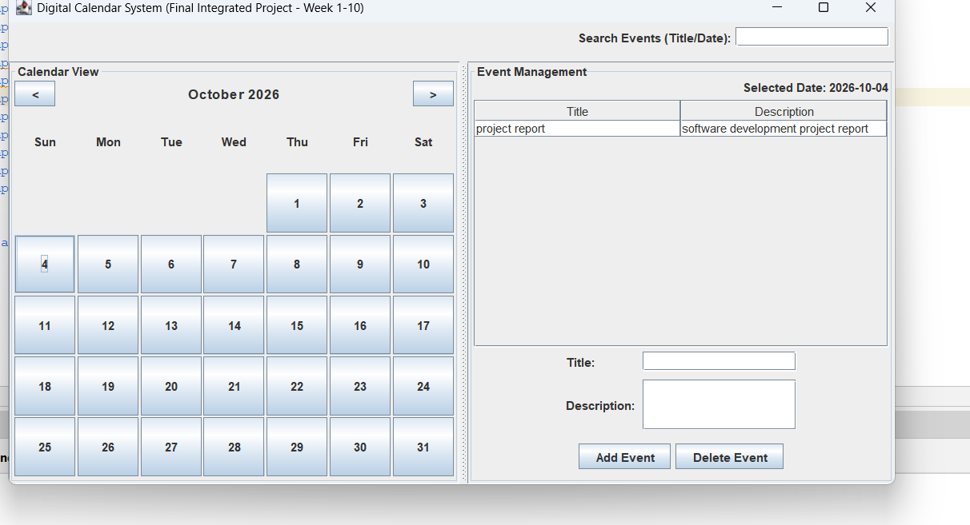
Figure: Main Digital Calendar System Interface

Project objectives:
To develop a desktop calendar application using Java.
To create a clear and user-friendly graphical interface.
To display a monthly calendar and support month navigation.
To allow users to create and view event details.
To support event editing and deletion in the planned integrated system.
To save event records to a local text file and load them at startup.
To validate required fields and date input.
To provide reminders where the reminder module is integrated.
To apply object-oriented programming principles and test the application.

Scope of the project:
The planned scope includes calendar navigation, date selection, event creation and viewing, event management, local file storage, reminders, and event search. The two supplied code samples are not identical: one includes month navigation, editing, and a startup reminder; the other includes a table view and stricter field/date validation but does not include editing or the monthly calendar. The report distinguishes planned features from features shown in the code.

Development methodology:
The project plan follows an incremental development approach. The application is divided into modules and developed in stages. The calendar interface and date selection come first, followed by event creation and viewing. Event management, file handling, reminders, search, testing, and documentation are scheduled for later weeks.

Flowchart:
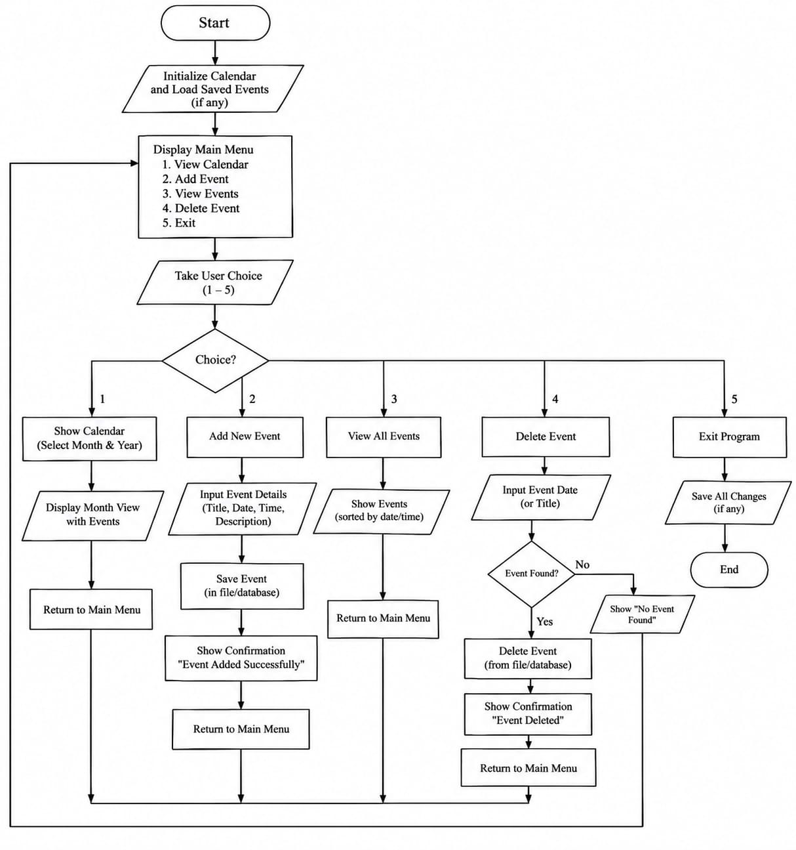
Figure:Digital Calendar System

System requirement:
Hardware: desktop or laptop computer, display, keyboard and mouse, and enough memory/storage to run Java and save application files.
Software: Java Development Kit (JDK), NetBeans or another Java IDE, Java Swing libraries, a compatible operating system, and Git/GitHub if version control is used.

System architecture:
The application uses a desktop GUI architecture. Swing components collect input and display calendar or event information. Event data is held in memory while the application runs and is read from or written to a local text file.
CalendarApp is the main application window and event-handling class. Event is the data model for an event. GUI components include JFrame, JPanel, JTable, DefaultTableModel, JList, JTextField, JTextArea, JButton, and JOptionPane. File handling uses Java reader/writer classes.
The second code sample declares package calendarapp and requires an Event class in that package. The final project should use one consistent code version and package structure.

Project structure:
A possible structure based on the supplied code is shown below. The exact folders depend on the IDE.
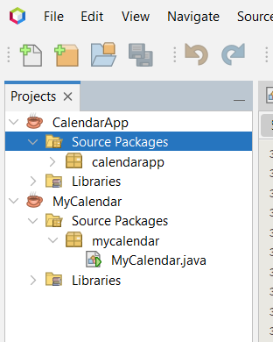
Figure:Project Structure in NetBeans

Object oriented programming concepts:
Event represents an event, and Event objects store individual records. CalendarApp represents the main application window.
Encapsulation: In the first code sample, Event fields are private and accessed through getter and setter methods.
Abstraction and Modularity: Methods such as createEvent(), deleteEvent(), saveEventsToFile(), and loadEventsFromFile() divide tasks into smaller units.
Event-driven programming: Action listeners respond to button clicks and call the related event-handling methods.

Data storage and file handeling:
The system uses events.txt instead of a database. At startup, the program checks whether the file exists and loads saved records. When an event is added or deleted, the event collection is written back to the file.
The first code sample separates date, title, and description with the pipe character (|). The second uses semicolons (;). These formats must not be mixed in the same file. A semicolon inside text can also interfere with parsing in the second sample.

Calendar and event work flow:
Typical launch the application; load saved records; select a date or enter a date in YYYY-MM-DD format; enter title and description; add the event; view it in a list/table; save the updated collection; and delete or edit events where supported.
The second code sample uses LocalDate.parse(date) to validate a date. It also checks whether the title, description, and date fields are empty. The first code sample obtains the date from the calendar table.

User Interface:
The supplied screenshot shows a monthly calendar on the left and an event-management area on the right. The right-hand area includes a selected-date label, an event list, and event-detail fields. A search field is also visible in the screenshot.
The second code sample uses a different layout: an event-entry form on the left and a scheduled-events table with Title, Date, and Description columns on the right. The supplied materials therefore represent different versions or stages of the application.

How to set up and run application:
Install a compatible JDK; open the project in NetBeans or another Java IDE; confirm that CalendarApp.java and Event.java are in the correct source folder/package; build the project and fix compilation errors; run CalendarApp.java; then create an event and check that events.txt is created or updated.
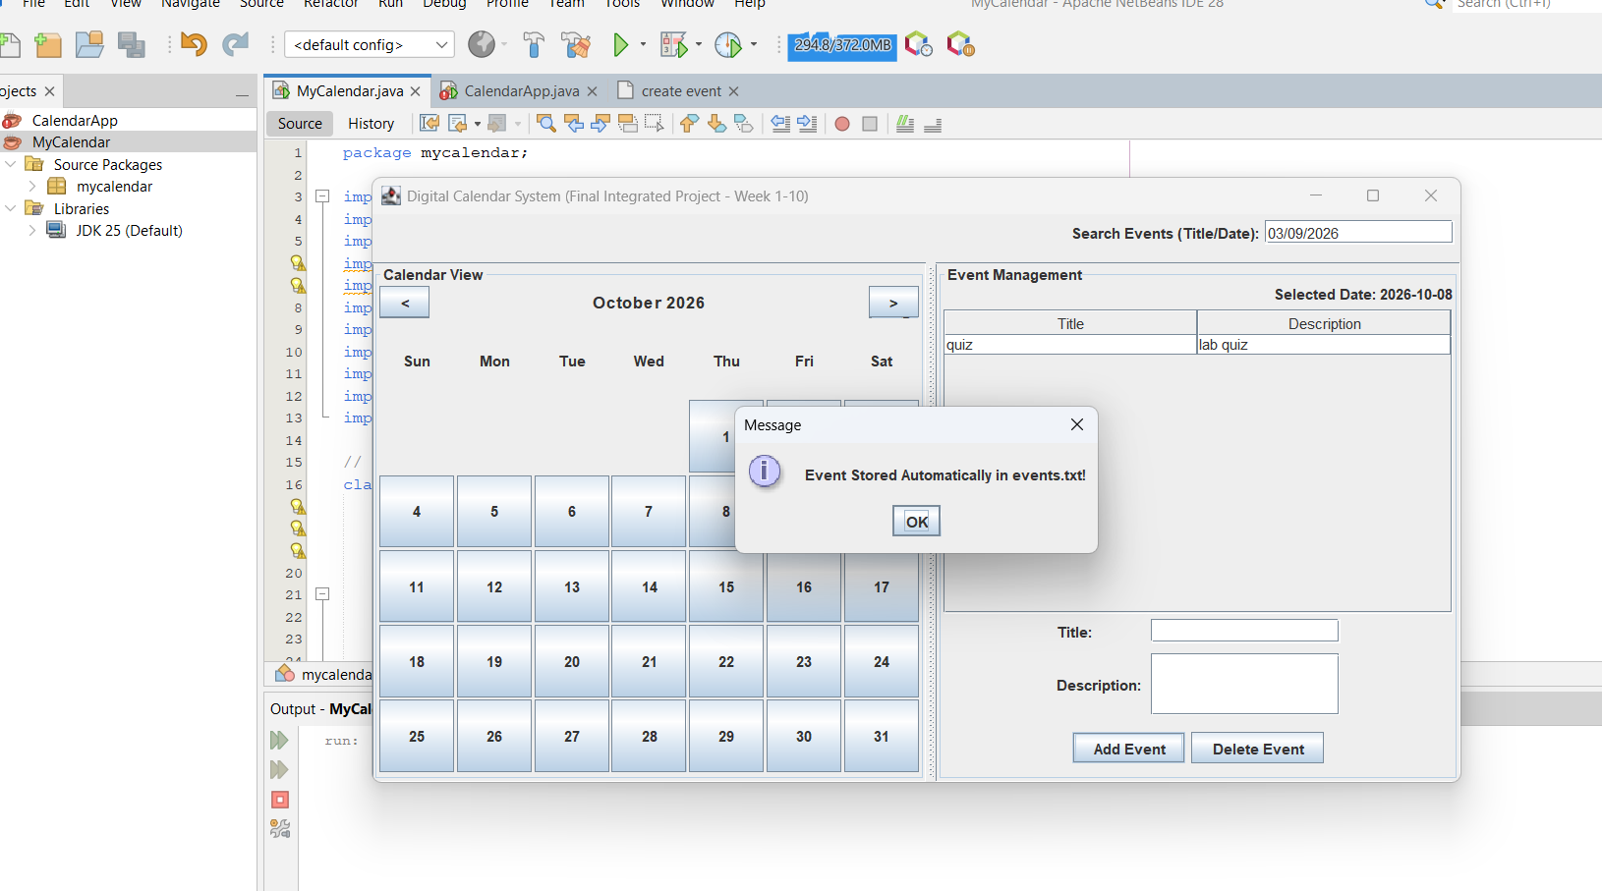
Figure:Event stored
Figure:Event Management System

How To Use The System:
Creating an event: open the application; select a date or enter it in YYYY-MM-DD format; enter the title and description; click Add or Add Event; confirm that the event appears and is saved.
Viewing/deleting: view events in the list or table; select an event or row; click Delete; confirm deletion if prompted; check that the event disappears and the file is updated.
Editing and reminders are available only in the first supplied code version. Its reminder popup checks events scheduled for today when the application starts.
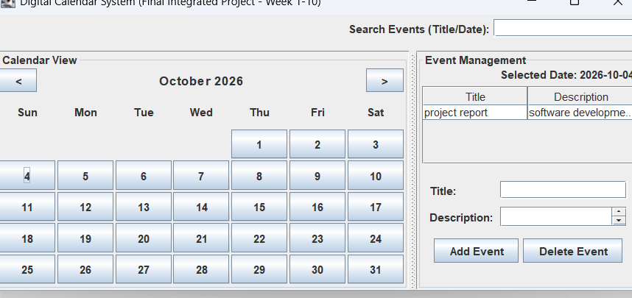
Figure:Final Output

Input Validation And Exception Handling:
The second code sample checks that all fields are filled in and parses the date with LocalDate.parse. Invalid dates produce a warning. The first sample checks that a date is selected and the title is not empty.
Deleting without selecting an event displays a warning. File I/O exceptions are caught and reported or printed. The first sample also displays a confirmation dialog before deleting. Better handling of malformed file lines and delimiters can be added.

Testing:
The following test cases should be executed on the final integrated version. Status is marked 'To be verified' because no test results were provided.

Github Version Control:
The project plan includes creating a GitHub repository in Week 1 and uploading the final version in Week 10. GitHub can store source files, documentation, and development history through commits. No repository URL was provided.
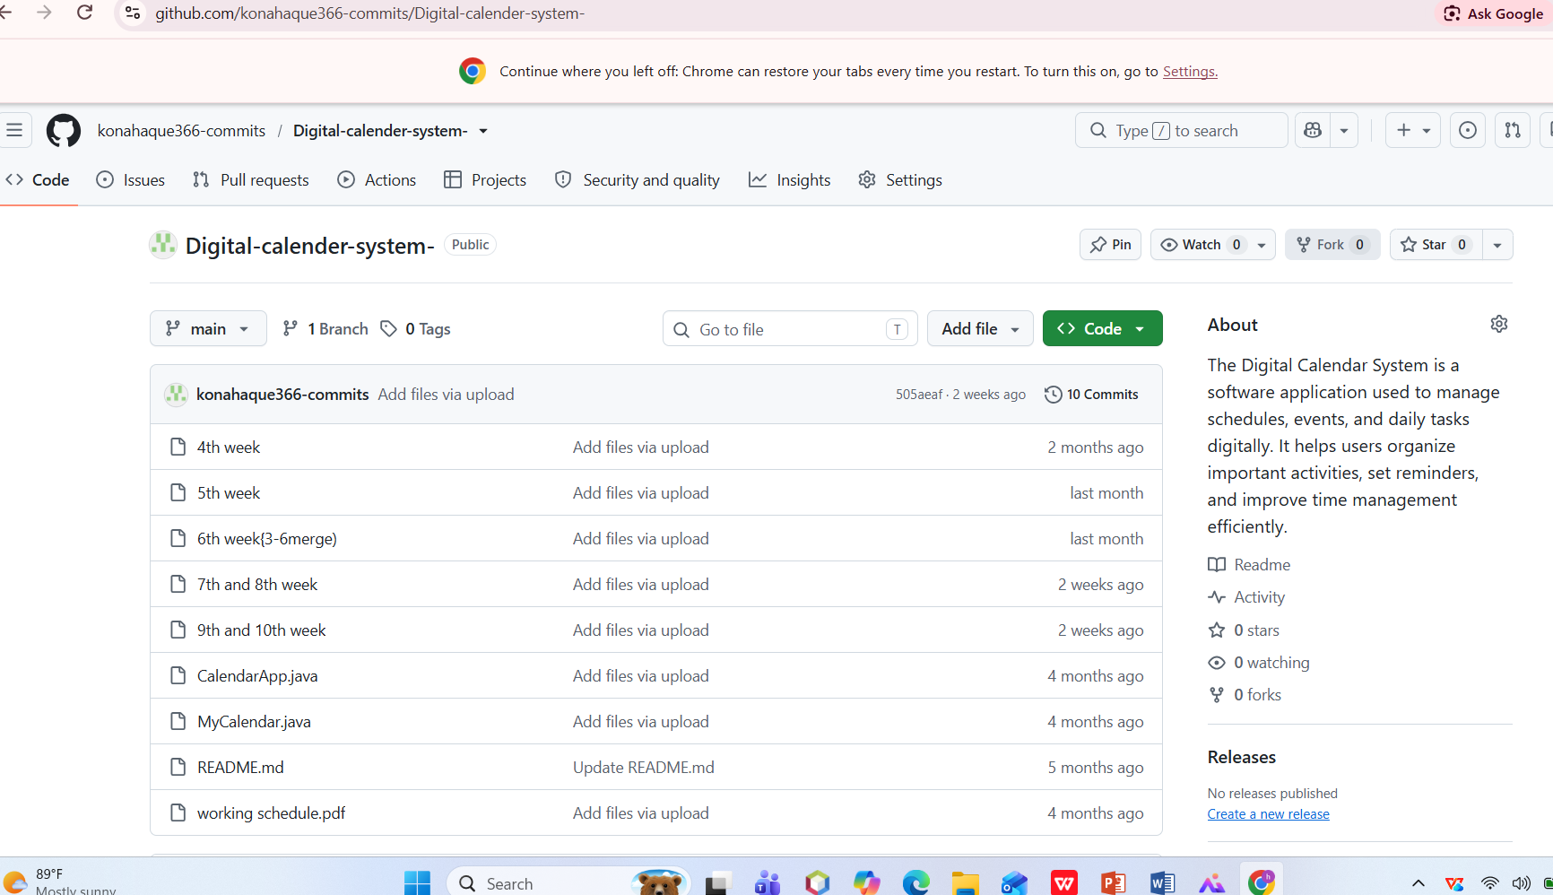
Figure:Github Report

Challenges Faced;
Designing the interface with Java Swing; synchronizing the in-memory list, table/list, and text file; validating fields and dates; loading saved data; handling different file formats; maintaining a consistent package structure; and testing the different versions.

Limitations:
The application is a desktop application and uses a local text file rather than a database. The two code samples differ in features and file formats and should be consolidated. Search logic is not present in the supplied code, although search appears in the plan and screenshot. Recurring events and multi-user synchronization are not demonstrated. The first sample checks only today's events at startup.

Future Improvements:
Integrate the calendar, event table, editing, and search into one consistent application; implement and test title/date search; add reminders for upcoming events; use a safer file format; add a date picker; improve visual design; add sorting/filtering; provide export and backup options; and add automated tests.

Result:
The supplied code demonstrates event creation, event display, deletion, and local file storage. One version also includes a monthly calendar, month navigation, editing, and a startup reminder. The screenshot shows a calendar-based interface and event-management area. The final result should be described according to the version actually compiled and demonstrated.

Conclusion:
The Digital Calendar System applies Java and Swing GUI components to event management. It demonstrates event-driven programming, data models, tables and lists, input validation, and file handling without a database. Before submission, the different code versions should be consolidated, features tested, and the report updated to match the verified final application.

Project demostration:
Launch the application; show the main window; navigate between months if supported; select a date and create an event; show the event in the list/table; demonstrate validation; delete an event; edit it if supported; restart the application to show file loading; demonstrate reminders and search only if implemented; and show the GitHub repository if available.
10 week Development Schedule:
Week | Main Tasks | Deliverable
1 | Planning, requirements, objectives, feature list, workflow, GitHub repository | Proposal and requirements
2 | Main window, calendar layout, navigation, Java Swing prototype | Basic GUI
3 | Monthly calendar, month navigation, current-date highlight, date selection | Calendar module
4 | Event form, title, description, date, validation | Event creation
5 | Show events for selected dates and event details | Event viewing
6 | Edit/delete events and confirmation messages | Event management
7 | Save to local file and load on startup | File storage
8 | Reminders and notification pop-ups | Reminder module
9 | Search by title/date and UI improvements | Search and improved UI
10 | Testing, bug fixing, documentation, presentation, final GitHub upload | Final software and report

Main Features:
Feature |  | Description / Evidence
Monthly calendar |  | First code sample provides a JTable calendar and Previous/Next month navigation.
Date selection |  | Selecting a date loads events for that date in the first sample.
Create event |  | Users enter an event title, description, and date.
View events |  | First version lists selected-date events; second displays events in a table.
Edit event |  | Present in the first sample; absent from the second sample.
Delete event |  | Both samples support deletion; the first asks for confirmation.
File storage |  | Events are saved to events.txt and loaded on startup.
Input validation |  | Both samples check required values; second validates date with LocalDate.parse.
Reminder |  | First sample shows a startup popup for events scheduled today.

System Requirements summary:
Test Case | Expected Result |  | Status
Launch application | Main window opens without an error |  | To be verified
Add valid event | Event appears and is saved |  | To be verified
Leave required field empty | Validation message appears |  | To be verified
Enter invalid date | Date warning appears in table version |  | To be verified
Load saved events | Previously saved events appear |  | To be verified
Delete without selecting | Selection warning appears |  | To be verified
Delete selected event | Event disappears and storage updates |  | To be verified
Edit event | Updated details are saved in first version |  | To be verified
Navigate month | Calendar month changes in first version |  | To be verified
Today's reminder | Popup lists today's events in first version |  | To be verified
Search title/date | Matching events appear if search is implemented |  | To be verified

